

**Home work**

**5.2,5.3,5.4**



**November 11, 2020**

**Raihan md rakibul islam**

**2020380029**

**5.2**

2. Use strong induction to show that all dominoes fall in an infinite arrangement of dominoes if you know that the first three dominoes fall, and that when a domino falls, the domino three farther down in the arrangement also falls.

**Answer:** **All dominoes fall in an infinite arrangement of dominoes**.

8. Suppose that a store offers gift certificates in denominations of 25 dollars and 40 dollars. Determine the possible total amounts you can form using these gift certificates. Prove your answer using strong induction.

**Answer:** we need to determine which amount can be made from 25 dollars to 40 dollars.

**$25** certificates **$40** certificates **Total**

1                                  0                                 $25

0                                  1                                 $40

2                                  0                                 $50

1                                  1                                 $65

3                                  0                                 $75

0                                  2                                 $80

2                                 1                                 $90

4                                  0                                $100

1                                  2                                 $105

3                                  1                                 $115

0                                  3                                  $120

5                                  0                                 $125

2                                  2                                 $130

4                                  1                                 $140

1                                  3                                 $145

6                                  0                                 $150

3                                  2                                 $155

0                                  4                                 $160

P(n) is the proposition that the

above amounts and every amount divisible by $5 from $140 up to $140 + $5n can be formed from the gift certificates. Suppose it's true for all the numbers up to some n (assumed to be greater than 4, since we proved P (0); P (1); P (2); P (3) and P (5) above. Since P(n_5) is true, we can add a $25 gift certificates to the method of making$140 _ $25 + $5n guaranteed by P (n - 5), and thus create $140 + $5n, proving P(n). Thus, by strong induction, we can form $25, $40, $50, $65, $75, $80, $90, $100, $105, $115, $120, $125, $130, and every multiple of $5 from $140 on.

14. Suppose you begin with a pile of n stones and split this pile into n piles of one stone each by successively splitting a pile of stones into two smaller piles. Each time you split a pile you multiply the number of stones in each of the two smaller piles you form, so that if these piles have r and s stones in them, respectively, you compute rs. Show that no matter how you split the piles, the sum of the products computed at each step equals n(n − 1)/2.

**Answer:**

**Inductive Hypothesis (Strong Induction):** Suppose for some k≥2k≥2, nn stones can be split in 2≤n≤k2≤n≤k stones and k−nk−n stones.

**Inductive Step**: Consider n=k+1

m(m−1)/2+(k−m)(k−m−1)/2+m(k−m)=m(m−1)/2+(k−m)(k−m−1)/2+m(k−m)=

m(m−1)+(k−m)(k−m−1)+2m(k−m)/2=m(m−1)+(k−m)(k−m−1)+2m(k−m)/2=

m^2−m+k^2−mk−k−mk+m^2+m+2mk−2m^2=

k^2−k/2=k(k−1)/2

∑k=1n−1k=(n−1)n/2

28. Let b be a fixed integer and j a fixed positive integer. Show that if P (b), P (b + 1), . . . , P (b + j ) are true and [P (b) ∧ P (b + 1) ∧···∧ P (k)] →P (k + 1)is true for every integer k ≥ b + j , then P (n) is true for all integers n with n ≥ b.

**Answer:**

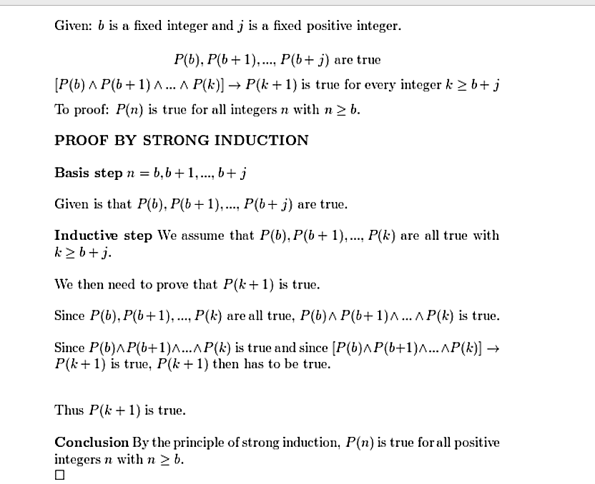

**5.3**

4. Find f (2), f (3), f (4), and f (5) if f is defined recursively by f (0) = f (1) = 1 and for n = 1, 2,...

a) f (n + 1) = f (n) − f (n − 1).

**0, -1, -1,0**

b) f (n + 1) = f (n)f (n − 1).

**1,1,1,1**

c) f (n + 1) = f + f

**2,5,33,1214**

d) f (n + 1) = f (n)/f (n − 1)

**1,1,1,1**

10. Give a recursive definition of(n), the sum of the integer m and the nonnegative integer n.

**Answer:**

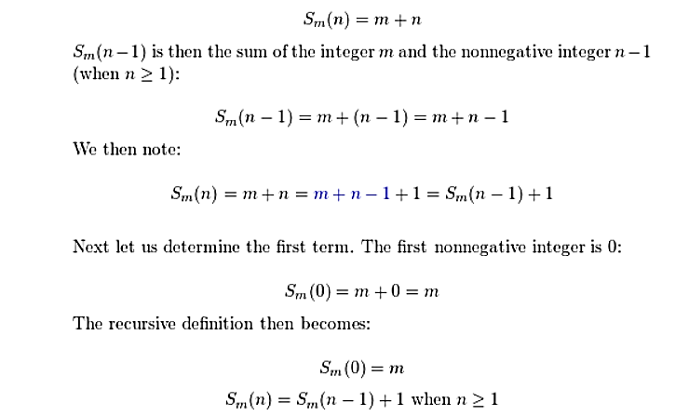

18. Let

A =

Show that

=

when n is a positive integer.

**Answer:**

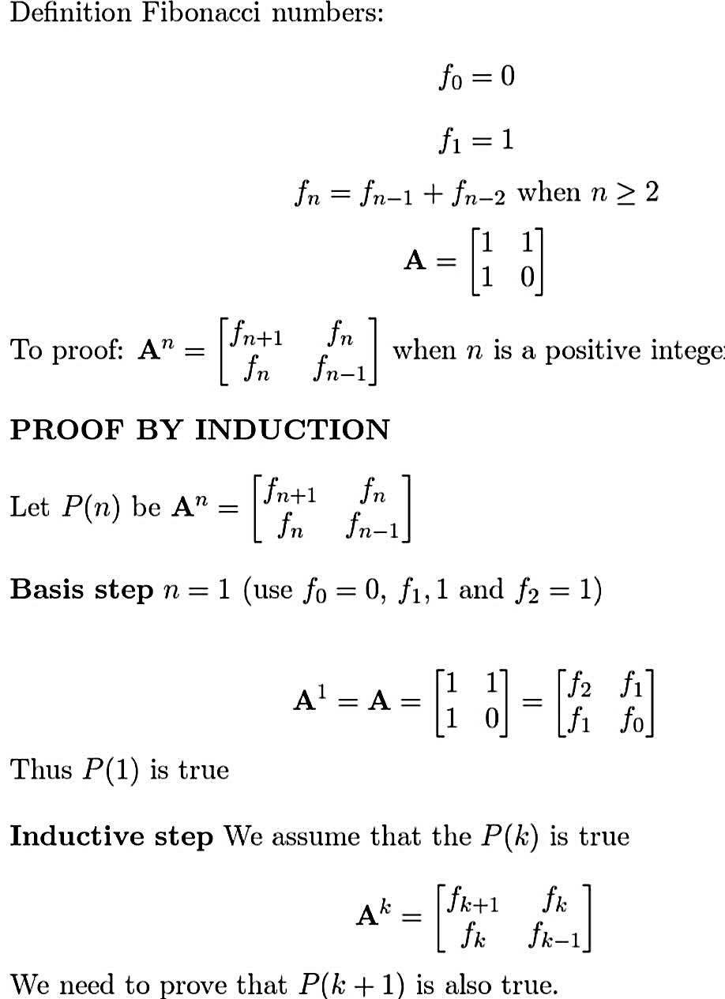

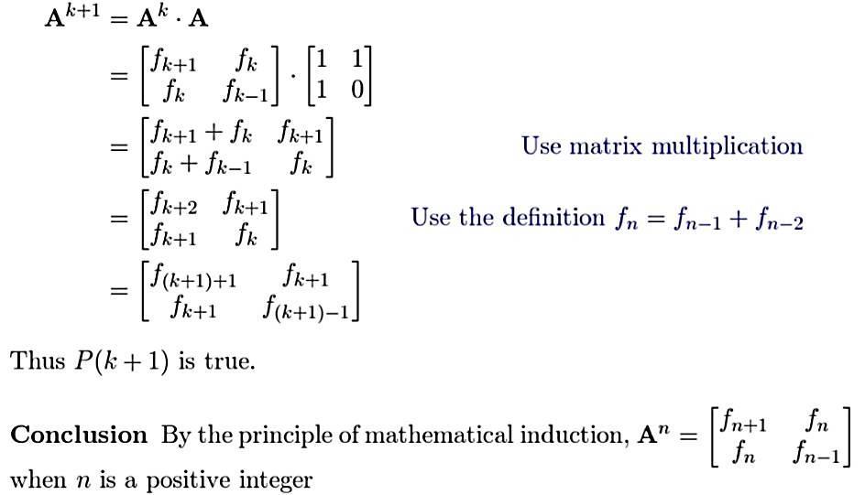

**5.4**

2. Trace Algorithm 1 when it is given n = 6 as input. That is, show all steps used by Algorithm 1 to find 6! as is done in Example 1 to find 4!

**Answer:**

5! = 5.4!

= 5.4.3!

= 20.3!

= 20.3.2!

= 60.2!

= 60.2.1!

= **120**

16. Prove that the recursive algorithm for finding the sum of the first n positive integers you found in Exercise 8 is correct.

**Solve:** 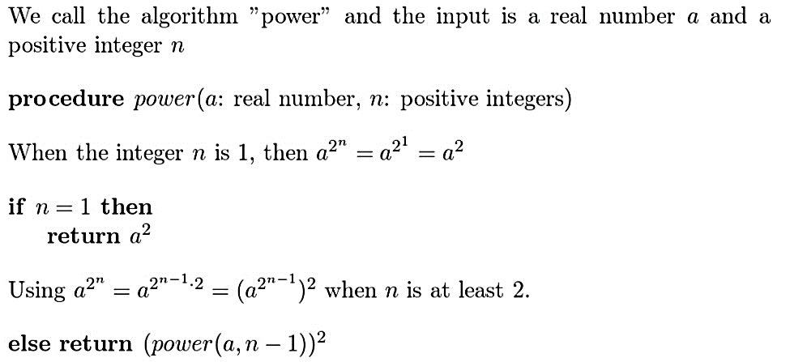

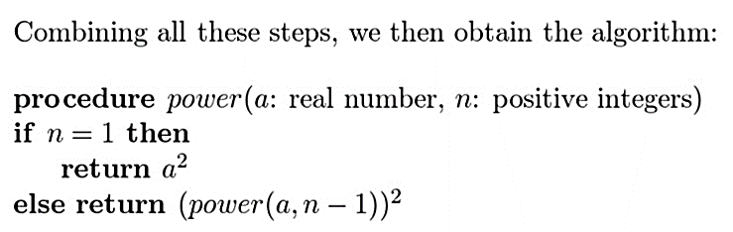

24. Devise a recursive algorithm to find , where a is a real number and n is a positive integer. [Hint: Use the equality = ].

**Solve:**

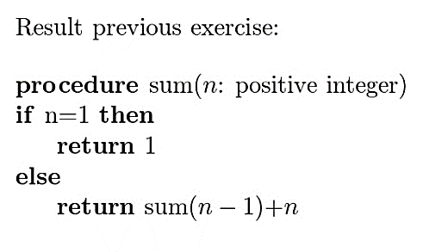

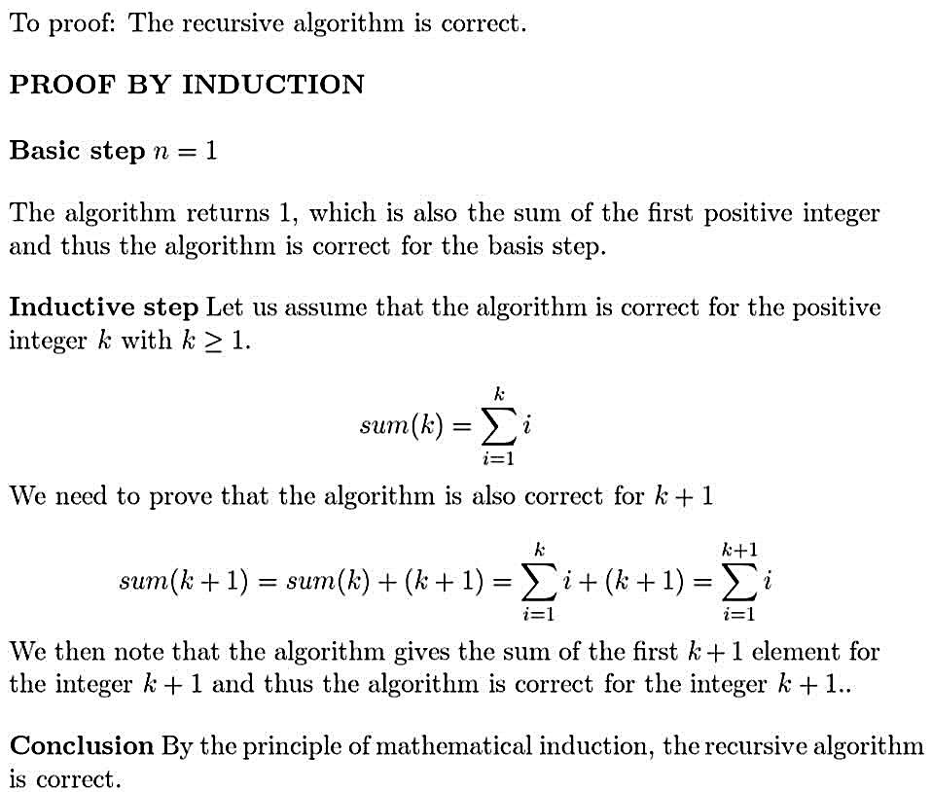

28. How many additions are used by the recursive and iterative algorithms given in Algorithms 7 and 8, respectively, to find the Fibonacci number f7?

**Solve:**

Algorithm 7 draw recursion tree:

7->6+5

6->5+4

5->4+3

4->3+2

3->2+1

2->1+0

3 gives you 2 addition, 2 gives you 1 addition

A therefore 4 gives you 4 addition

Therefore, 5 gives you 4+2+1 addition (7) and gives you 12+7+1 additions =20

Algorithm 8 is an iterative approach

To find f7 must have some sort of loop that runs at least 7 times.

Therefore, algorithm 7 will do 20 additions, and algorithm 8 will do 7 additions.